**Past iGEM pages:**

* <https://2020.igem.org/Team:GreatBay_SCIE> the organization of this, especially the logos which are clicked to take site visitors to the various pages
* <https://2020.igem.org/Team:GreatBay_SZ> this website is giving me Avril Lavigne, but I like the way they have a continuous stream of information as you scroll (this overall format seems to be the best in my opinion)
  + <https://2020.igem.org/Team:TUDelft> another example but this one has a lot going on
* I like the way the SDU Denmark has subcategories within each respective category that can take you to those individual pages (<https://2019.igem.org/Team:SDU-Denmark/Project>)

**Color Schemes:** (any of the websites that are red and black seem too intense and scary whereas those with lighter color schemes are more pleasant to look at; I feel like a good balance of warm and cool tones looks the best as opposed to some websites that do all blue/green, etc.)



(HTML codes: 264653, 2A9D8F, E9C46A, F4A261, E76F51)



(HTML codes: D7263D, F46036, 2E294E, 1B998B, C5D86D)

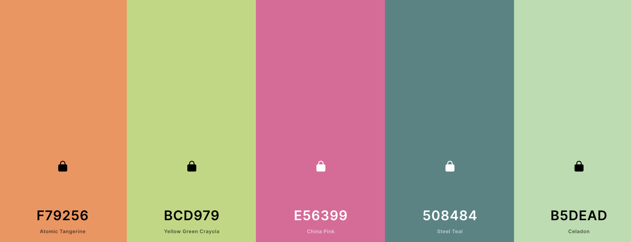

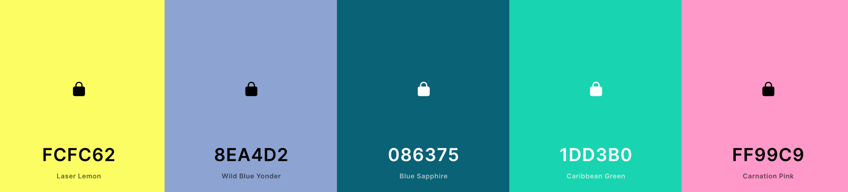

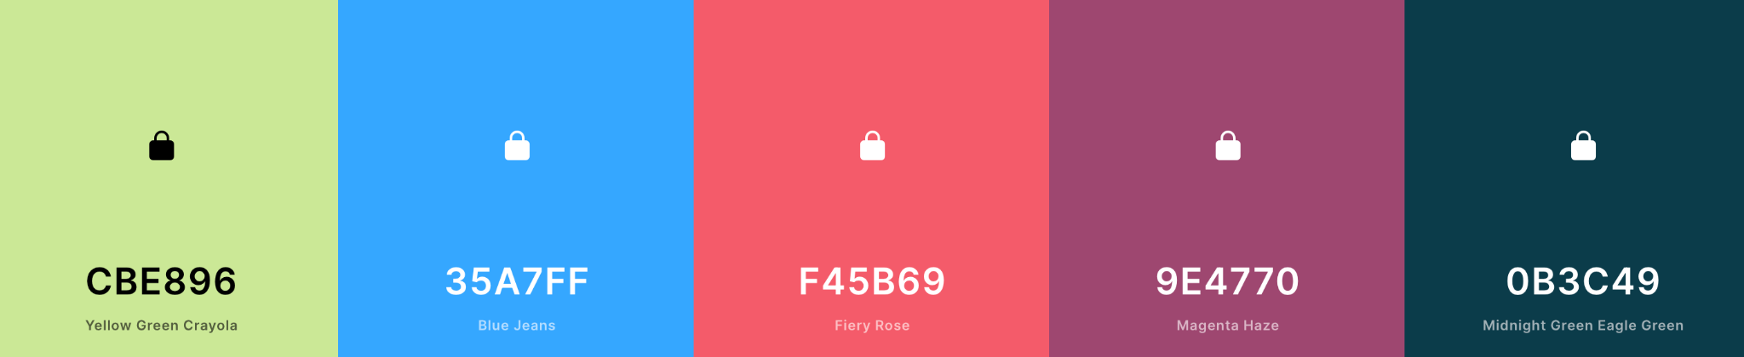

I think more bright may be better so the site doesn’t look dull/moody

**Miscellaneous:**

* Websites seem to look the best when they have a header with a graphic at the top of the page as opposed to immediately getting into the bulk of the material without anything to catch the eye/garner interest
  + <http://2018.igem.org/Team:Calgary/CRISPR> this one goes right into the content
  + <https://2020.igem.org/Team:Vilnius-Lithuania> whereas this page has a graphic (a moving one; pretty dope) that makes you want to continue looking at the page
* putting this here to veto it entirely
* Graphics relating to CRISPR-Cas9 system, E.coli, plasmids, transformation, etc
  + BioRender has a handful of good graphics relating to the CRISPR system as well as templates that can be used to help outline the process when explaining it on the wiki page
  + There is also the capability to change the color of many of the components of each icon
  + 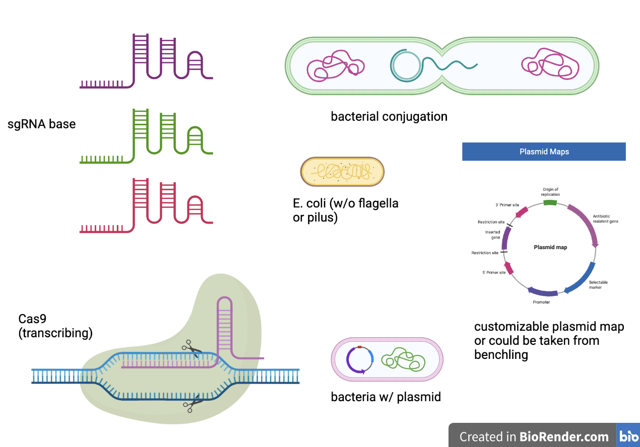

**Overall Ideas:**

* Continuous flow website
* The bar along the top is built into iGEM websites but we could add an additional one much like SDU Denmark that allows easier traversing of the website and the different subcategories (also the iGEM one looks archaic)
* Or we could have a continuous scroll with these icons along the very bottom like the mushroom project, but this may not be as wise as some people could not scroll all the way to the bottom to access these/be unaware that they are there
* Organize the different sections into subgroups to keep the website more organized overall
* Start of the site with an image that grabs attention as opposed to immediately going into the content
  + What should this image/graphic be? Probably not a picture of an infection
* Find a way to make moving graphics of these systems
  + For example, a gif of the process of conjugation and having the linearized plasmid travel from one bacterium to another; could be tea
* Categories (not necessarily in this order): Introduction, Team, Project, Modeling, Results, Human Practices

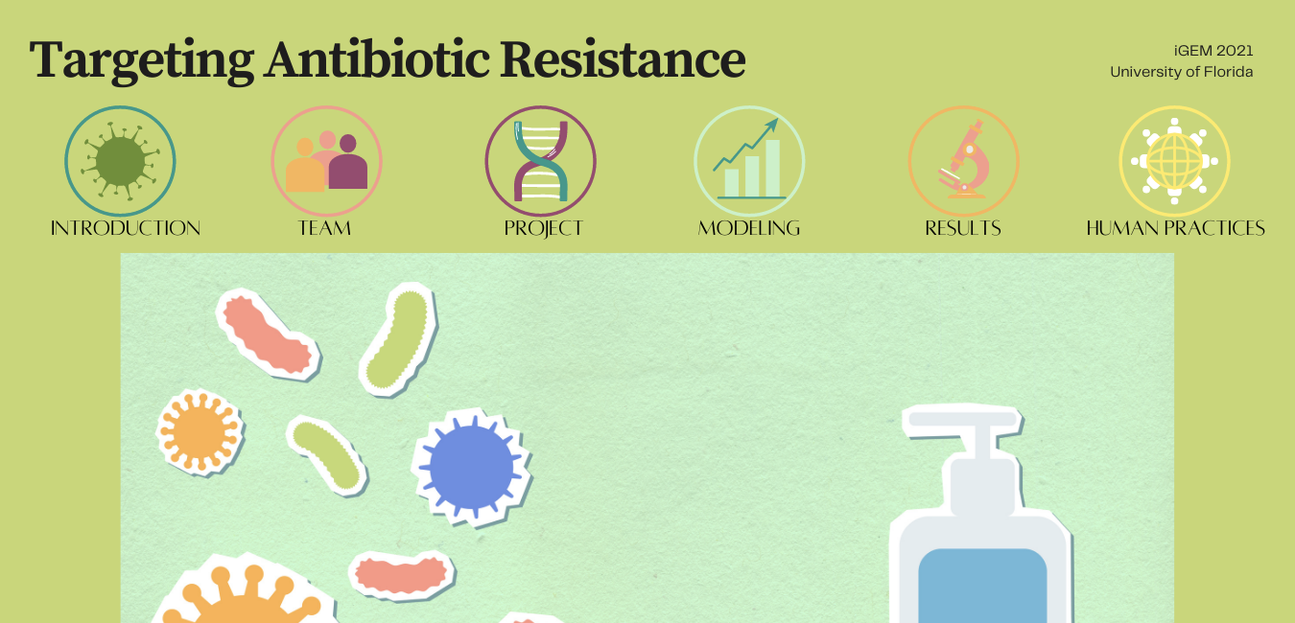

This is a random picture at the bottom (kind of reminds me of the show Little Bill), but I like the idea of having the logos along the top. Obviously, it would look more technologically cool than this I just made this in Canva, but you get the gist. Then, you could scroll and have things move around and look dope :^)

The logos for each of the section headers would need to be more cohesive, these were just ones present in Canva